Спортска гимназија

Београд, Херцег Стјепана 7

МАТУРСКИ РАД ИЗ ЕНГЛЕСКОГ ЈЕЗИКА

Urban Arts

Ментор: Ученик:

Снежана Николић, *проф.* Савић Ана ${IV}_{4}$

Београд, јун 2023. год

Table of Contents

1. Introduction 3

2. What is urban art? 4

3. Forms of urban art 5

3.1. Graffiti – the pillar of hip-hop 5

3.2. Murals 7

3.3. Stickers 8

3.4. Posters 9

3.5. Chalk art 10

3.6. Tags 10

4. The rise, fall, and redemption of urban arts 12

4.1. Rising through centuries 12

5. Most famous graffiti and murals 14

5.1. Girl with ballon 14

5.2. Crack is wack 14

5.3. Flower Thrower 15

6. Conclusion 16

1. Introduction

The nature of the human being is no better than animals, we are not excluded from its laws, deep down in our core there is a strong desire to mark territory, to make it ours. You may think we have overcome it by now, but the next time you go out in the street, have a look around; suddenly you will notice all the graffiti, stickers, name tags, and posters and realize they are no different than prehistoric cave paintings and pictographs. Urban arts have been around for centuries and they have become an integral part of contemporary culture.

1. What is urban art?

Urban art is a form of self-impressing art with the purpose of sending a meaningful message to a large number of people, like any other art. It is usually found on buildings, sidewalks, and trains. Urban art contains graffiti, street art, murals, stickers, posters, and others.

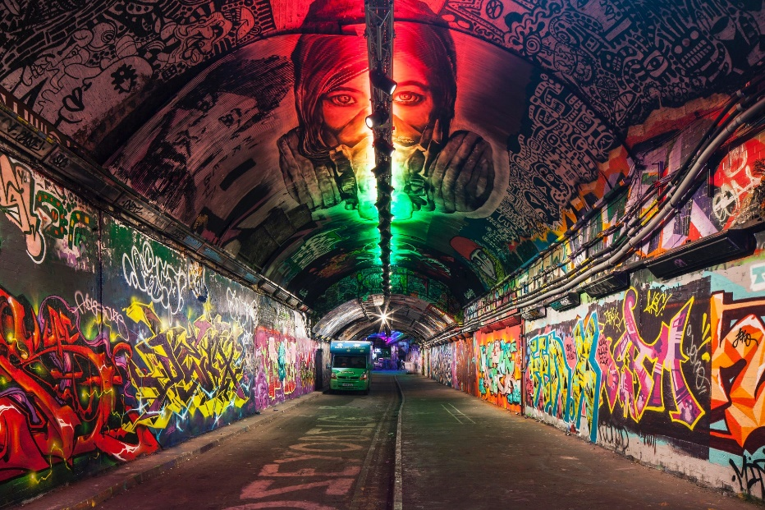The common misconception is that street art and urban art are the same. The big difference is that street art is only on the street and urban art is not strictly tied to the strets, and it belongs to the citizens rather than just the artist.

Figure 1 Leake Street

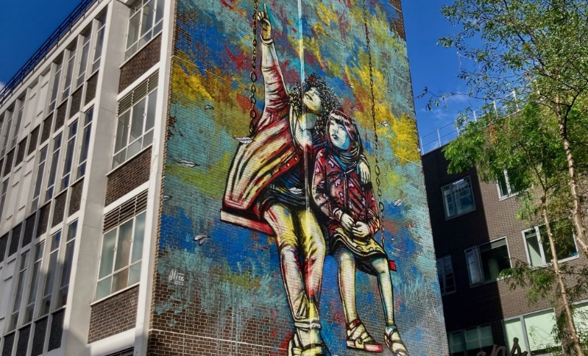

Figure 2 Generation Equality Mural by Alice Pasquini on Johnson Gardens

1. Forms of urban art
   1. Graffiti – the pillar of hip-hop

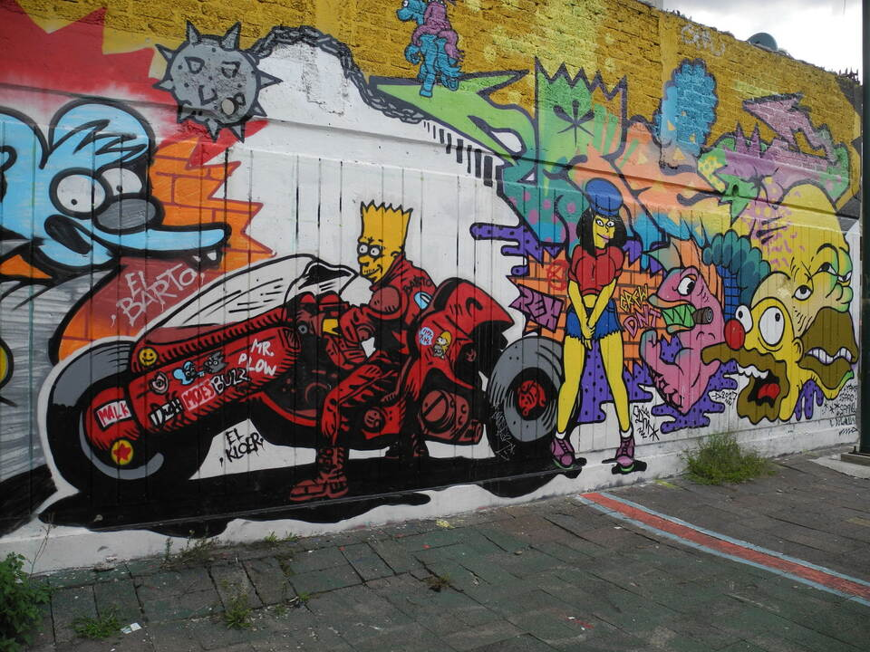Graffiti emerged as one of the four pillars of hip-hop in the 1970s. It was essential to the culture and was a deep-rooted, meaningful mode of expression for artists. Graffiti is a creation of art that portrays people’s emotions, artistic expression, characters, or creative words. Graffiti is a common type of street art that is mainly done on public walls on city streets – typically without any prior permission. It is commonly done as an act of rebellion, marking territory, making a statement, or raising awareness.

Figure 3 Wall in the Infonavit Iztacalco district, Mexico

Derived from the Italian word graffio (“scratch”), graffiti has a long history. As an illustration, markings have been discovered in medieval English churches, ancient Roman ruins, the ruins of the Mayan city of Tikal in Central America, and 16th-century Spanish rocks. Graffiti during the 20th century in the United States and Europe was closely associated with gangs, who used it for a variety of purposes: for claiming or identifying territory, for remembering deceased gang members in an informal "obituary," for bragging about acts (such as crimes) committed by gang members, and for challenging rival gangs as a prelude to violent confrontations. Throughout the world's major cities, graffiti was particularly prevalent.

The practice of "tagging," a new variation of graffiti that first appeared in the 1990s, involved repeatedly marking a specific area with a single symbol or group of symbols. This kind of graffiti typically appeared in neighborhoods that were purposefully or centrally positioned to garner as much attention as possible.

According to some observers, graffiti is a type of public art, carrying on the tradition, for instance, of the murals commissioned by the Federal Art Project of the U.S. Works Progress Administration during the Great Depression and Diego Rivera's work in Mexico.

Graffiti is illegal in most countries since it is considered vandalism, and the penalties can be severe. For instance, violators in Singapore face caning. In the 1980s and 1990s, many authorities worked to prevent and remove graffiti out of concern that it would otherwise degrade the neighborhood. A lot of money was spent on cleanup and abatement projects, and some communities even started mural programs or "free walls" to give urban teenagers a legal outlet for their artistic expression

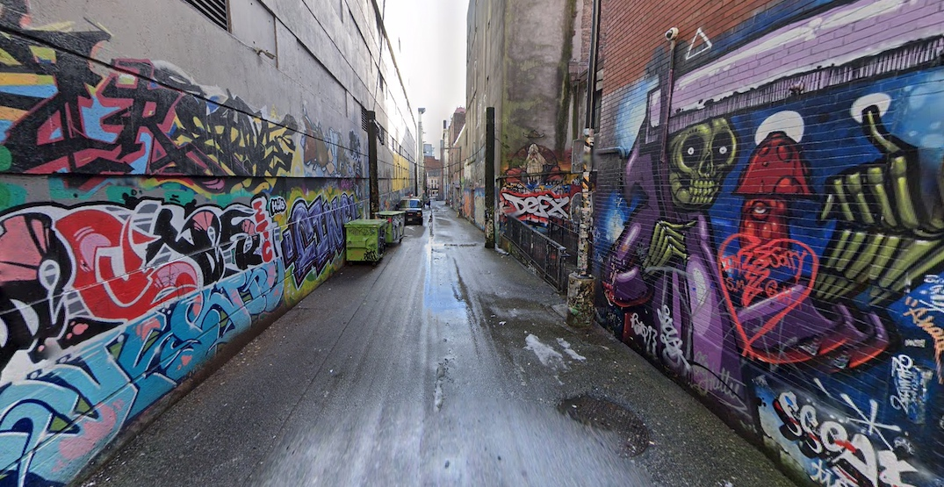

Figure 4 City of Vancouver free-for-all graffiti areas

* 1. Murals

Murals are enormous works of art that cover most of a building facade or other city wall. Murals are created with much more detail and they are far more complex, contrary to graffiti, they require permission. They represent an instrument of liberation, freedom of speech, social action, and propaganda. In Serbia, they are often in memorial to an important member of a group. Painting murals on walls is seen as a crucial component of the socially relevant art and has a big impact on how politics and art interact.

Mural painting has a long history that dates back to the Stone Age. It might be argued that murals originated as cave paintings in the Upper Paleolithic, which could be more than 12,000 years old. Except for Antarctica, every continent has murals. Ancient murals can teach us a lot, especially about the traditions and daily lives of those times.

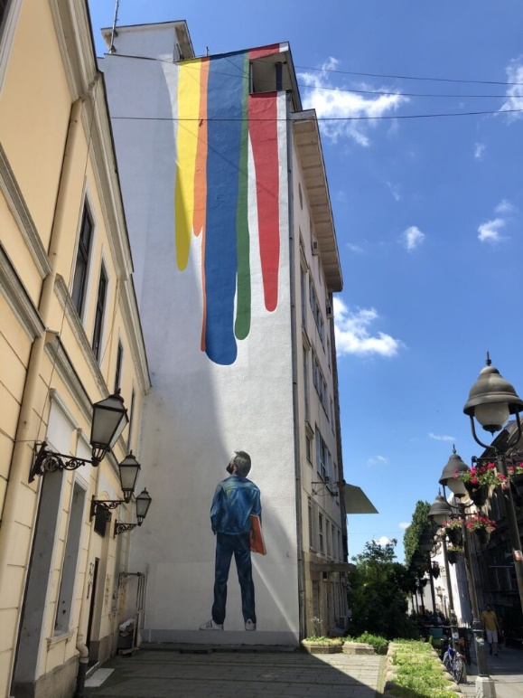Murals are important because they can provide us with a glimpse into the past and the future. They have been utilized throughout history and continue to act as an indication of presence now. They all follow a similar pattern: they portray society as it was at the time they were made, whether they are painted over old brick and mortar constructions or cover the inside walls of historic buildings.

Murals are utilized to express independence and forge connections between art and politics in modern society. While many businesses try to use murals as a form of meaningless advertising, there are many regions of

Figure 5 Perica Donkov, Student koji gleda u zid

the world, including South America, where murals are valued as an essential component in producing captivating artworks that encourage viewers to consider the possible political, social, or religious messages a mural might be trying to convey. The right design for a mural can now be created using a stencil, acrylic, oil, paste-ups, wheat pasting, and other techniques.

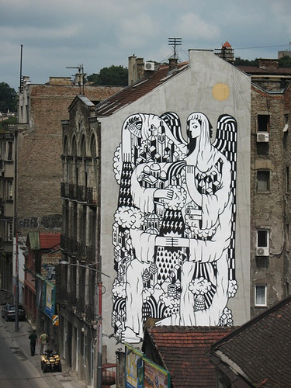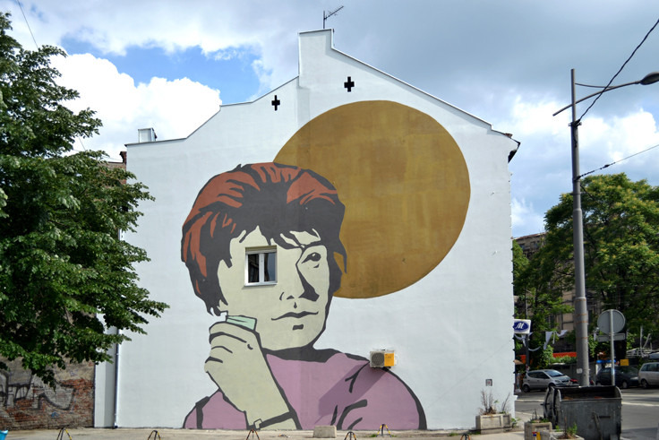

Figure 6 REMED, La santa de Beograd

Figure 7 Cekajuci sunce, Beograd

* 1. Stickers

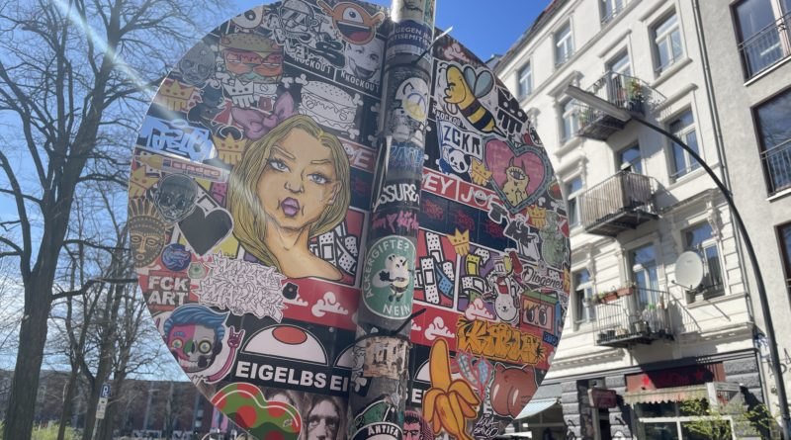Some artists have carried this idea to the streets from our childhood pastime of decorating our hands and books with stickers. They create eye-catching stickers in various sizes and adhere them on benches, buildings, trees, and lightposts in the streets. While some stickers are designed to be easily removed, others are made to last a long time. Some people regard the 1990s as the heyday of sticker culture. The number of sticker artists was growing, broadening the definition of sticker art to encompass everything from custom skateboard stickers to expansive wheat-paste murals. In the neighborhood sticker art communities, stickers were still primarily hand-drawn and traded. Today's stickers have undergone a significant aesthetic shift as a result of the development of modern technology.

Figure 8 Urban art in Hamburg

* 1. Posters

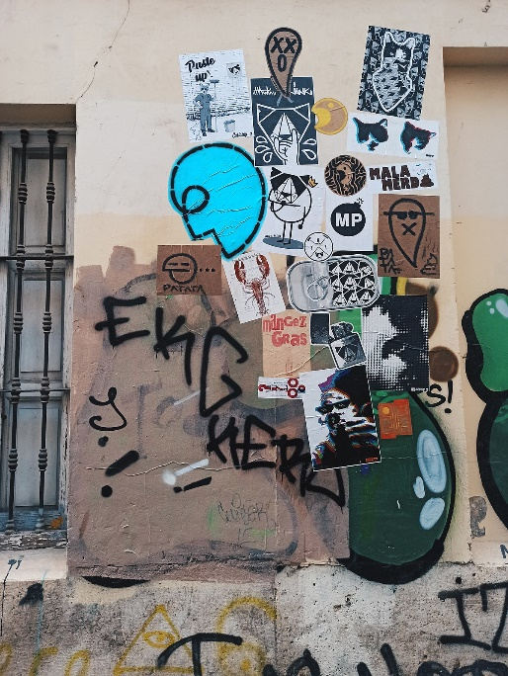A style of 2D illustration known as poster art is printed or hand-drawn on large sheets of paper. Posters are made by artists using calligraphy and imaginative artwork. These wall-mounted posters are typically used to alert visitors about impending events. Today's poster art is produced on a computer, printed on paper, and then ready to be displayed in crowded regions.

Figure 9 Street poster combo in Valencia, Spain

* 1. 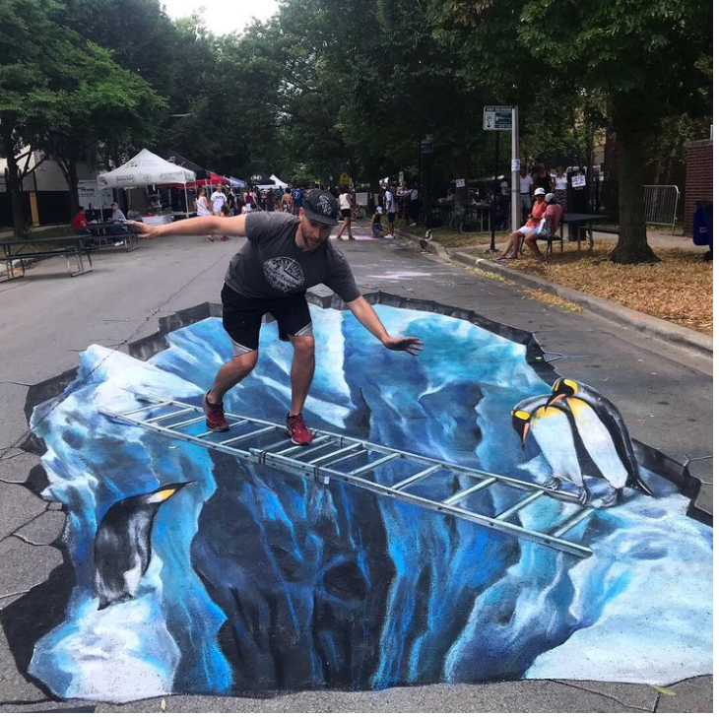Chalk art

There are many great artists that can paint lifelike pictures on the sidewalks. Moving closer will reveal that what initially appears to be a genuine figure standing across the street is actually just an extended piece of graffiti. The most basic form of sidewalk art is made up of fake potholes. Since chalk art is permitted, which is what made it so famous, you should take a moment to admire it before moving on because rain could wash it away at any time.

Figure 10 Chalk Howard Street in Chicago by Nate Baranowski

* 1. Tags

One of the main types of graffiti, along with throw-ups and pieces, is the use of tags. Tagging is the process of writing a tag. Tags are frequently regarded as the most basic form of graffiti art, prioritizing legibility and flow, and are typically the form of graffiti that most artists begin with.

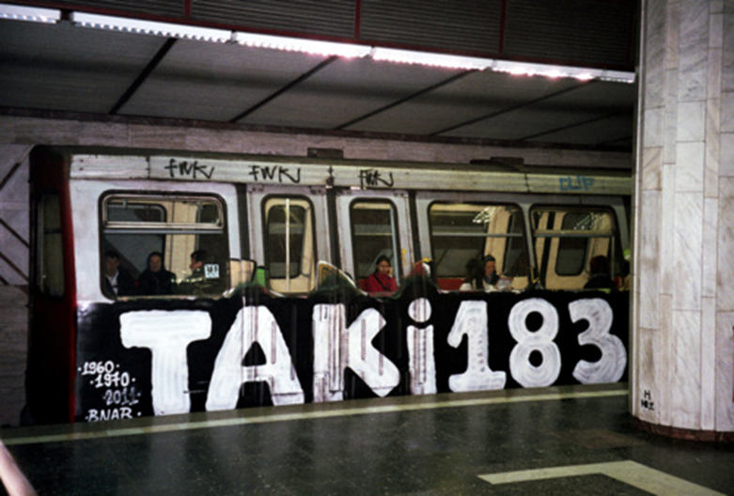

Figure 11 Tag TAKI 183

Tags were the first form of modern graffiti, emerging in New York City in the 1960s and 1970s with artists like TAKI 183 and Julio 204. Tags are more likely to be regarded as vandalism than other more intricate graffiti forms, possibly because of their simplicity. As many influential street artists at the time battled for attention by writing their nicknames and pseudonyms in a distinctive way with an original design, the mid-1970s witnessed the growth of several styles. Photographer Martha Cooper is one of the most renowned figures to have done so; only few artists were able to capture the creative process and the early impetus of street artist societies. She began capturing the street art scene and street artists in New York in the 1970s, and she also made a significant contribution to the growth of the entire movement by disseminating her book, Subway art, which was published in the early 1980s. Cooper's compact paperback version immediately turned into a style manual for graffiti artists and train writers not just in the 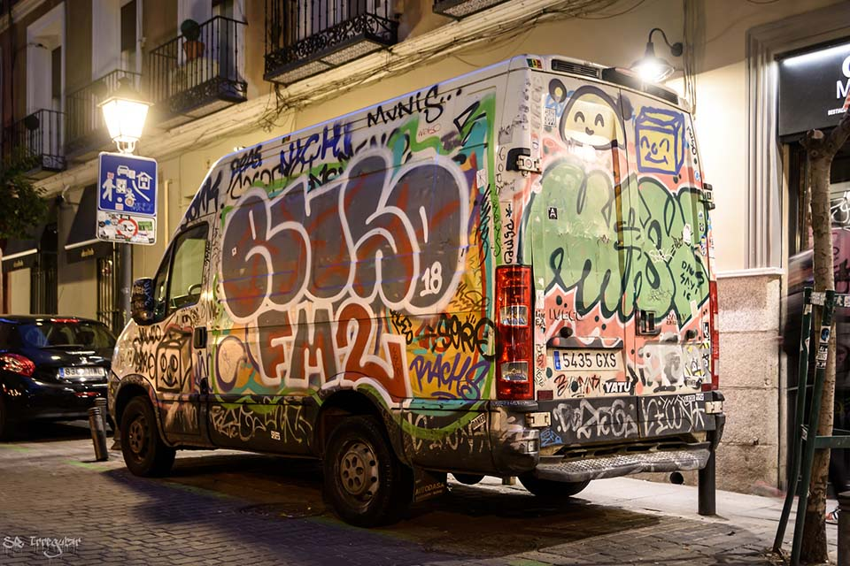United States but also in other countries.

Figure 12 Malasaña, Madrid

1. The rise, fall, and redemption of urban arts

* 1. Rising through centuries

The earliest graffiti can be found in the 30,000-year-old cave paintings and pictographs made using colors and implements like animal bones. In the caverns, these representations were frequently positioned in religious and ceremonial areas. In most cases, the drawings on the walls depicted scenes of animal wildlife and hunting adventures. In contrast to today's well-known statements of social and political values, ancient graffiti include pledges of love, political rhetoric, and straightforward thought.

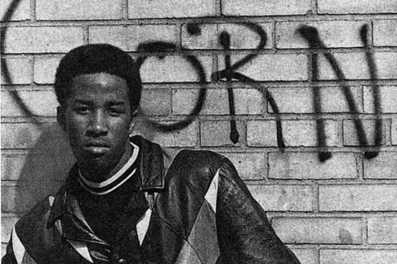 Graffiti was a popular method of expression for political activists in America in the late 1960s. Gangs like the Savage Skulls, La Familia, and Savage Nomads also utilized graffiti to designate their area. Graffiti and hip hop are related because early graffiti artists used other hip hop features and because it was popularized in locations where other hip hop components were developing as art forms.

Figure 13 Cornbread, widely regarded as the father of modern day graffiti

The relationship between graffiti and hip hop culture arises both from early graffiti artists practicing other aspects of hip hop, and its being practiced in areas where other elements of hip hop were evolving as art forms.

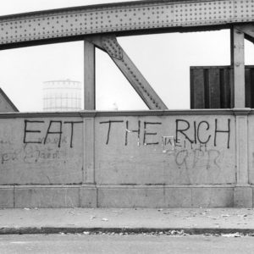Modern graffiti culture first developed during the political and cultural revolutions of the late 1960s and early 1970s, which are also the origins of contemporary urban art. Street Art in the decades that followed had a clearly political bent, and today's urban artists continue to be heavily influenced by this subversive undertone. The London Underground was covered in anti-war, anarchist, feminist, and anti-consumerist messages between 1970 and 1980.

Figure 14 The Writing on the Wall By Roger Perry

As graffiti art flourished, as was to be expected, anti-graffiti campaigns were launched by city officials to protect private property or maintain the city's "clean" image. In the 1990s, a lot of effort and resources were devoted to eradicating graffiti in New York City. However, efforts to control graffiti art were largely fruitless because erasing graffiti was expensive and effectively aided artists by providing them with a blank canvas. Cities shifted toward beautifying techniques of graffiti control after years of fruitless "clean up attempts," hiring artists to paint murals on top of graffitied walls, and designating particular locations for street art.

The distinctions between graffiti art and more traditional artistic techniques started to become less distinct as public perception regarding graffiti began to shift. Then, something that had once been a public annoyance was being added to the canon of beautiful art. Street art had begun to be taken off from walls and presented at prominent art galleries.

1. Most famous graffiti and murals
   1. Girl with ballon

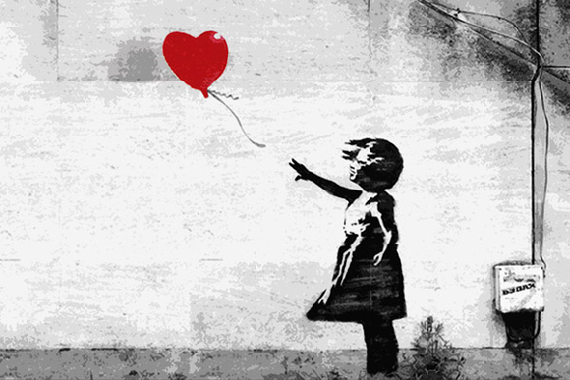Undoubtedly the most well-known graffiti artist of all time, Banksy has done more to advance the genre than anybody else. Balloon Girl, the most well-known graffiti piece ever, is a London landmark. It depicts a young girl grasping for a heart-shaped balloon that is being blown away while her hair and clothes are flying in the wind. The artwork was taken down from the east London store where it was painted and sold for £500,000 in 2014. A print of the photograph brought in £56,250 in 2015. And a survey conducted in 2017 revealed that it was the preferred piece of art in the UK.

Figure 15 Girl with ballon, Banksy

* 1. Crack is wack

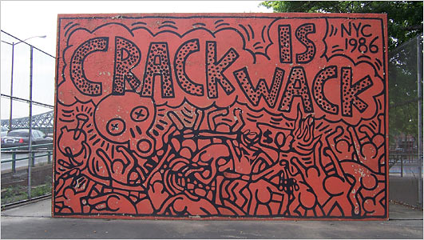Midway through the 1980s, crack cocaine use became a major issue in the New York City region, and artist Haring was personally affected by addiction through his friend Benny who was abusing the substance heavily. The piece of art was painted close to Harlem River Drive, but the artist was taken into custody because he lacked authorization. However, Haring was a well-known artist at the time, and the mural itself was widely publicized on television at a time when Ronald Reagan's "War on Drugs" campaign was in full swing. As a result, when word spread that he was in jail, people came to his defense. Haring paid a $100 fine and was let go. After Crack is Wack was defaced with pro-drug messages, the city eventually gave Haring permission to restore the artwork for the intended purpose. vandalized with pro-drug messaging and so eventually, the city allowed Haring to recreate the mural with its original purpose.

Figure 16 Crack is wack, Haring

* 1. Flower Thrower

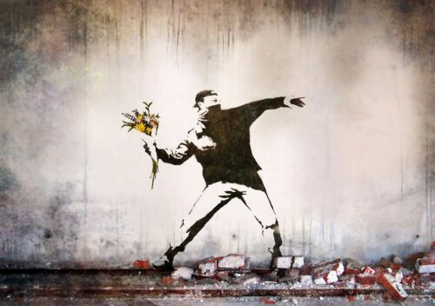This graffiti by Banksy, which is mostly in black and white (apart from the flowers), sends a strong statement. The work, which is set in the war-torn city of Jerusalem, shows a rioter who is ready to hurl a bunch of flowers rather than a bomb. The picture is so well-known that it has been printed, replicated on T-shirts, and included in a 2005 collection of Banksy's artwork titled Banksy Wall and Piece.

Figure 17 Flower Thrower, Banksy

1. Conclusion

In conclusion, urban art has emerged as a powerful and influential form of self-expression that has integrated itself into contemporary culture. The human desire to mark territory and leave a lasting impression is evident in the proliferation of graffiti, stickers, murals, posters, and chalk art that adorn our urban environments. While urban art may be viewed by some as vandalism or a nuisance, it is important to recognize its historical roots and its significance as a platform for social and political commentary.

The rise, fall, and redemption of urban arts demonstrate their dynamic nature. Graffiti and street art have undergone transformations through political and cultural revolutions. While efforts to control graffiti have often been met with resistance, the distinctions between graffiti art and traditional artistic techniques have blurred and today

governments even embrace it. Street art has transitioned from public annoyance to recognized art form, with renowned artists like Banksy leading the way. Urban art serves as a platform for self-expression, social commentary, and political activism. Its historical roots, evolution, and impact on urban environments make it an important art form that continues to shape and reflect the world.

1. References

<https://www.eden-gallery.com/news/history-of-urban-art> <https://en.wikipedia.org/wiki/Urban_art>

<https://blocs.xtec.cat/streetart/history-of-graffiti/history-of-graffiti-1/#:~:text=The%20earliest%20forms%20of%20graffiti,sacred%20locations%20inside%20the%20caves>.

<https://www.eden-gallery.com/news/graffiti-vs-mura>

<https://muralappreciation.com/murals/mural-vs-graffiti/>

<https://www.kooness.com/posts/magazine/urban-art-street-art#:~:text=The%20themes%20and%20purpose%20are,up%20by%20many%20different%20people>.

<https://en.wikipedia.org/wiki/Reverse_graffiti>

<https://taurangastreetartfestival.nz/7-different-types-of-street-art/>

figure 1 <https://static.arocdn.com/Sites/50/banksidehotel/uploads/images/offerssmall49/offerssmall36/london-graffiti-tunnel.jpg>

figure 2 <https://i0.wp.com/www.ec1echo.co.uk/wp-content/uploads/2022/11/image0-1-scaled.jpeg>

figure 3 <https://previews.agefotostock.com/previewimage/medibigoff/c23b055e53d1a63820ed381ba9410597/pah-180810-99-501340-dpai.jpg>

figure 4 <https://images.dailyhive.com/20220609121239/vancouver-graffiti-wall-laneway-f-1024x529.jpg>

figure 5 <https://www.gradnja.rs/wp-content/uploads/2020/07/Beogradski-murali-iz-osamdesetih-godina-2.jpg>

figure 6 <https://belguest.rs/wp-content/uploads/2018/07/Belgrade-street-art-tour-Waiting-for-the-sun-Aleksandar-Macasev.jpg>

figure 7 https://www.flickr.com/photos/remed_art/2777203633/

figure 8 <https://takemetogermany.de/wp-content/uploads/2022/04/Sticker-Art-Hamburg-11-800x445.jpg>

figure 9 <https://en.wikipedia.org/wiki/File:Wheat_paste_valencia.jpg>

figure 10 <https://images.squarespace-cdn.com/content/v1/53d27022e4b01ef7480e581d/1587400010154-IXN3J7855BQOBLI3GPUQ/AFC0FFAE-36EC-4364-BC46-A7B35BCF2C33.jpeg?format=1000w>

figure 11 <https://www.wikiart.org/en/taki-183/metro-tag>

figure 12 <https://cooltourspain.com/wp-content/uploads/2020/06/van-with-tags-and-graffiti.jpg>

figure 13 <https://d16kd6gzalkogb.cloudfront.net/magazine_images/Cornbread2.jpg>

figure 14 <http://www.allweatherartist.com/images/eattherich-crop-u62692.jpg?crc=4079786200>

figure 15 <https://www.dragopublisher.com/wp-content/uploads/2019/10/Girl-with-heart-ballon-bansky-1024x512.jpg>

figure 16 <https://static01.nyt.com/images/2007/09/05/nyregion/05haring.span.jpg>

figure 17 <https://static.wixstatic.com/media/32b0d7_cfa63966a3ce4d3db383af5bd40ff351~mv2.jpg>

